Dockerfile

Docker build

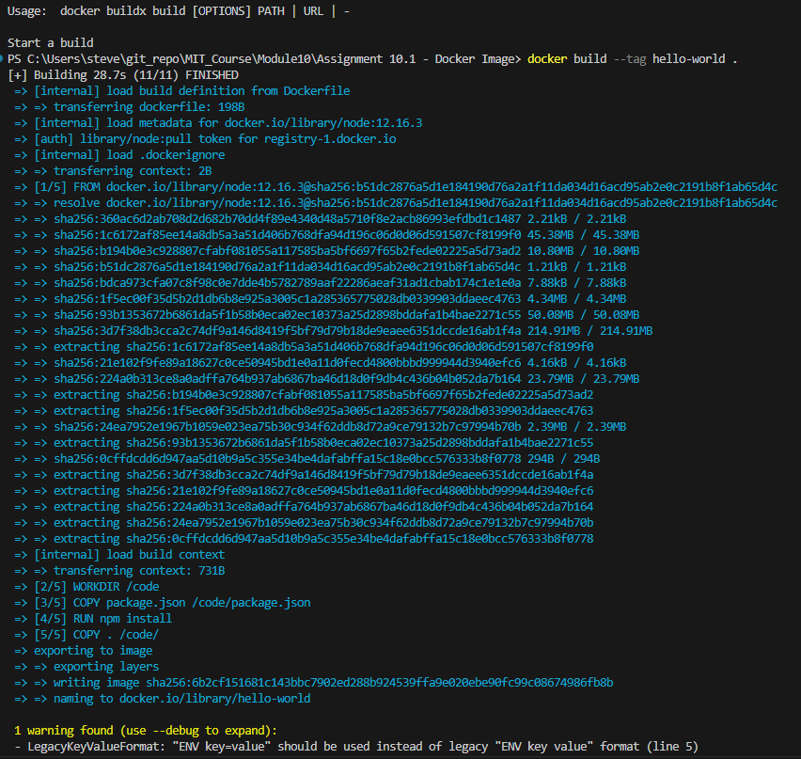

Docker images command

Docker run command



Localhost image

